

**MET2001 System Engineering Project 1**

**Trimester 3, Academic Year 23/24**

Demo 3 Report

**Group:** 04

**Prepared by:**

| Group Members | Registration Number |
| --- | --- |
| Bellamy Woo Zhen Yu | 2301579 |
| Chai Ze Xuan | 2301629 |
| Shaun Ong Zhi Peng | 2301632 |
| Muhammad Ariff | 2301644 |
| Low Min Wei | 2301555 |

**Table of Contents**

**1. Introduction** **2**

**2. Importance of wall-hugging/line-following robots** **2**

**3. ECE Problem Statement** **3**

3.1 Customer Specifications 3

3.1.1 Provided Robot Base 4

3.1.2 Provided MCU 5

3.1.3 Sensors 7

3.1.4 Light Module 8

3.1.5 MP3 Module 8

3.2 Integration to meet Demo 3 Requirements 9

3.2.1 Software Integration 9

3.2.2 Hardware Integration 10

3.3 ECE Task assignment 11

3.3.1 Code Integration 11

3.3.2 Unit Testing 12

3.3.3 Wiring of electrical components 13

3.3.4 Baseboard and Power Distribution Board Soldering 13

**4. Literature Survey** **15**

4.1 Research Survey 15

4.1.1 Line Follower Robot 16

4.1.2 Autonomous Wall Hugging Robot 17

4.2 Analysis and Comparison 17

4.2.1 Light Distance Sensor 17

4.2.2 Ultrasonic Sensor 19

4.2.3 Motor Control Board 20

**5. Algorithm** **20**

5.1 Code Design. 23

1. Efficiency through Abstraction 23

2. Interrupt-Driven Design 23

3. User Defined Functions and Maintainable Design 23

5.2 Implementation of Code 24

5.3 Testing of Application 27

5.3.1 Testing Methodology 28

5.3.2 Results 29

**6. Validation** **30**

**7. Conclusion** **30**

7.1 Reflection and Learning Points 30

7.2 Team Contributions 30

# 1. Introduction

Magni is a hardware platform in the form of a mobile base. When powered by ROS software, it can handle vision, localization, communication and mobility which is key to every robotics application. Magni also packs strong motors and a rock-solid chassis so that one can focus on the application and not the drivetrain.

The scope of this project is to utilise the Magni Robot to complete a course autonomously at the end of week 13. Some basic introductions of the robot are as follows. It is powered by two 200W motors, and it is able to support a speed of 2m/s with capabilities of moving payload of 100kg. Additionally, in order to power the robot, two 12V lead-acid batteries are connected in series and the robot has a threshold rating of up to 32Ah which is able to support normal operation up to 24 hours. The frame of the robot is built by sourcing off-the-shelf-parts from various vendors and it also comes with Raspberry Pi 4 which can be installed with Ubuntu 20.04 and Robot Operating System (ROS)3 . This was chosen as it supports user friendliness due to having an open source and a large online community for support.

For the electrical and electronics component of the Magni Robot, the main PCB is the Motor Control Board. It has two power sources, 5V and 7V and both can output 7A each.

# 2. Importance of wall-hugging/line-following robots

Wall-hugging and line-following robots are particularly important in environments where precise, localised navigation is required without relying on external systems like GPS, LiDAR, or Computer Vision (CV). Here are the reasons why these robots are significant:

1. **Indoor Navigation**: GPS signals are often weak or unavailable indoors, making GPS unreliable for navigation. Wall-hugging and line-following techniques allow robots to navigate through structured indoor environments, such as corridors and rooms, using local sensors.
2. **Cost-Effectiveness**: Using simpler sensors like ultrasonic or infrared for wall-hugging and line-following is generally less expensive than implementing a full LiDAR or CV system. This makes it suitable for applications where cost is a constraint.
3. **Simplicity and Efficiency**: Wall-hugging and line-following algorithms are straightforward to implement and require less computational power compared to CV-based navigation systems, which need significant processing for image recognition and analysis.
4. **Environment-Specific**: In some environments, especially those that are highly structured like warehouses, factories, or hospitals, wall-hugging and line-following are more efficient because they rely on physical markers (walls, lines) that are guaranteed to be present, unlike GPS which may be affected by obstacles or reflections, or CV which might struggle with poor lighting or cluttered scenes.
5. **Reliability and Robustness**: These techniques are generally more robust to environmental changes, such as variations in lighting or obstructions that could interfere with LiDAR or CV systems. This makes them reliable in dynamic and cluttered environments where those more advanced systems might fail or require frequent recalibration.

By focusing on wall-hugging and line-following strategies, engineers can design robots that are reliable, cost-effective, and efficient for specific applications, particularly in indoor or controlled environments where GPS, LiDAR, or CV may not be practical or necessary.

# 3. ECE Problem Statement

## 3.1 Customer Specifications

The scope of the project is the customer’s requirement for the robot to autonomously traverse the given walled circuit at least twice clockwise and twice anti-clockwise, at 25 ticks/100ms. Below are the various rules for this project and it is as follows.

* Robot should not enter “restricted area” at any point during operation.
* Upon pressing the user button on the STM32G474RE Nucleo board, the robot should start moving.
* Both Light modules should blink at 2Hz consistently while in motion.
* MP3 module should sound off useful warnings when the robot is too near to a wall.
* Wiring and components should be neatly secured.
* Components mounted on the PVC board should incoporate a standoff.
* Demo any extra features if applicable.
* At any point of time in the traversal, an instructor shall place an obstacle in front of the robot. Your robot should stop within 20cm of the obstacle. When the obstacle is removed, your robot should resume the traversal.

### **3.1.1 Provided Robot Base**

* Magni Silver Robot Base

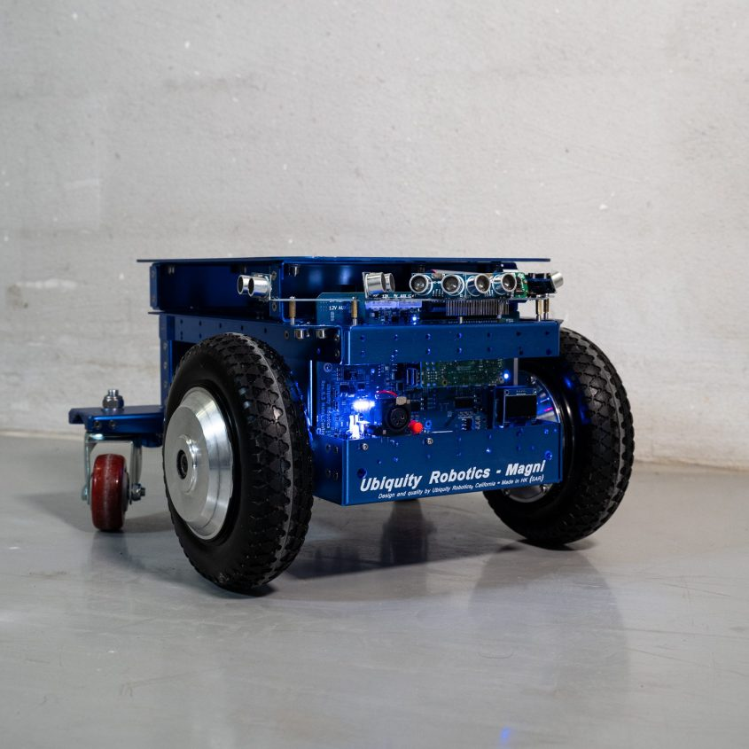

**Figure x: Visual representation of the AMR**

**Magni Components**

* Chassis
* Master control board (with motor controller, 2X5V 7A power supplies, 2X 12V 7A power supplies, 2 electronic circuit breakers, safety system, power distribution system, signal distribution system)
* Wheel assemblies (Motor, Magnetic Odometry, wheel and Tyre mounted on an M14 axle) Switchboard
* Raspberry Pi based computer

**Magni Specifications**

* Weight
  + 13 Kg
* Dimensions
  + L x W x H
  + 43.91 × 41.74 × 26.5 cm

### **3.1.2 Provided MCU**

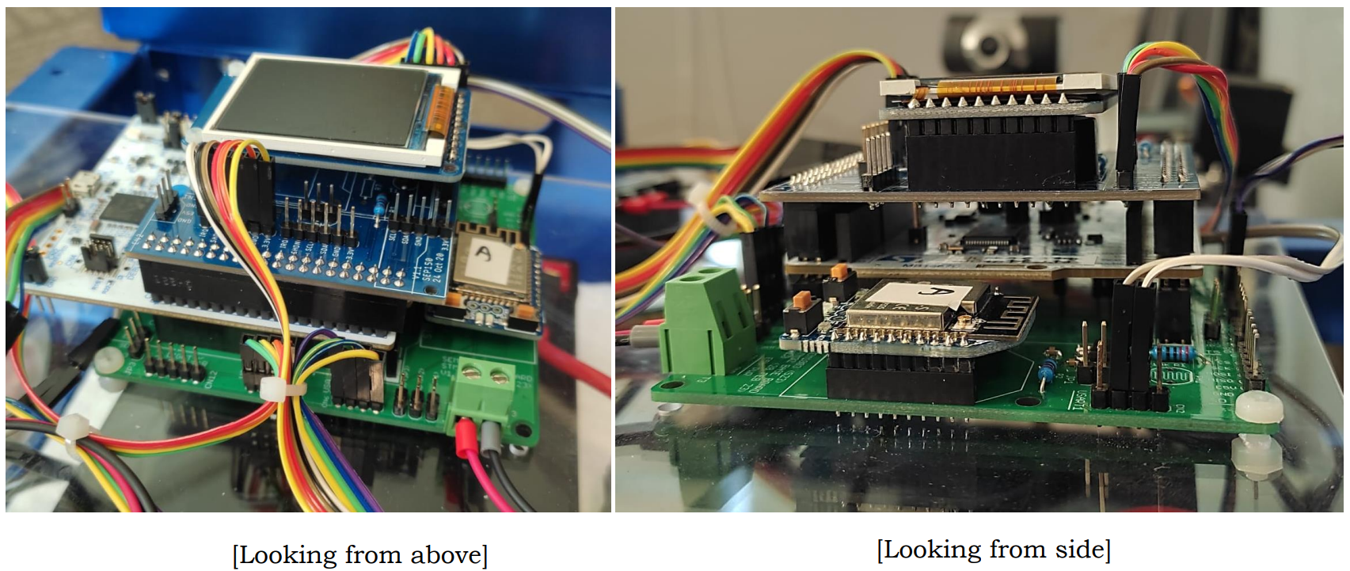

**Figure x: Visual representation of the MCU from various angles**

1. **STM32G474 Microcontroller**

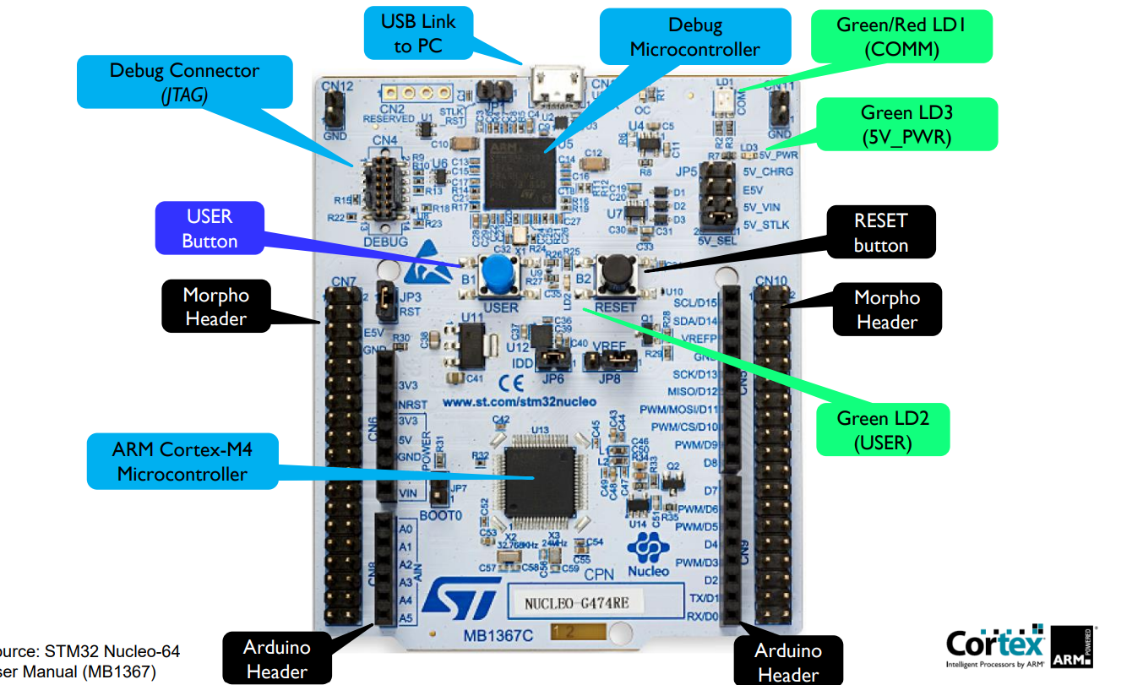

**Figure x: Visual representation of the STM32G474 microcontroller**

**STM32G474 Microcontroller Specifications:**

* 170MHz ARM Cortex-M4 processor
* 512K bytes of embedded Flash memory (defines program size limit)
* 96K bytes of SRAM with parity check
* GPIO Ports A to D: Configured as inputs, output , alternate-functions
* Multiple Timers: Basic, General-Purpose, Advanced Control, Advanced Control, Low-Power, High-Resolution.
* 2 sets of External Connectors: Arduino-compatible & Morpho
* 1 user LED (green)
* 1 user button (blue)
* 1 RESET button (black).
* Operating Voltage: 1.71V to 3.6V
* On-board Debugger

**STM32G474 Microcontroller Power Sources:**

* USB port (through laptop/PC)
  + Power (+5V) to the Nucleo board can be provided through the USB port that connects to the laptop/PC
  + The USB port is also used as a STLink-V3 connection for program download & debugging.
* External 5V source (E5V) – connect through CN7, pin 6.
  + STM32G4 Nucleo board can be powered from an external +5V source (E5V) that connects to CN7, pin 6.
* External 5V USB charger – connect through CN1.
  + An external USB charger can provide +5V power (+5V) to the Nucleo board through the USB port.
* External 3.3V power supply (3V3) – connect through CN7, pin 16.
  + STM32G4 Nucleo board can be powered from an external +3.3 source (3V3) that connects to CN7, pin 16.
* External VIN source (7V – 12V) – through CN7, pin 24.
  + STM32G4 Nucleo board can be powered from an external VIN source and used to generate a +5V source to power the Nucleo board.

1. **Mezzanine Board**

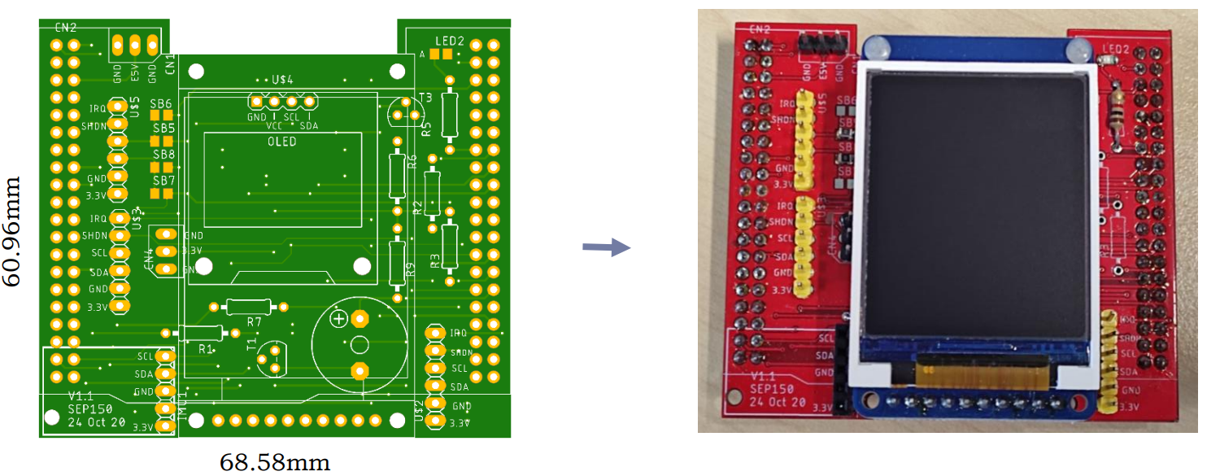

**Figure x: Visual representation of Mezzanine Board**

The mezzanine board will sit on top of the STM32G474RE Nucleo board. This board provides electrical connections to the LCD display (240 x 160mm) and up to 3 ToF sensors.

1. **Baseboard**

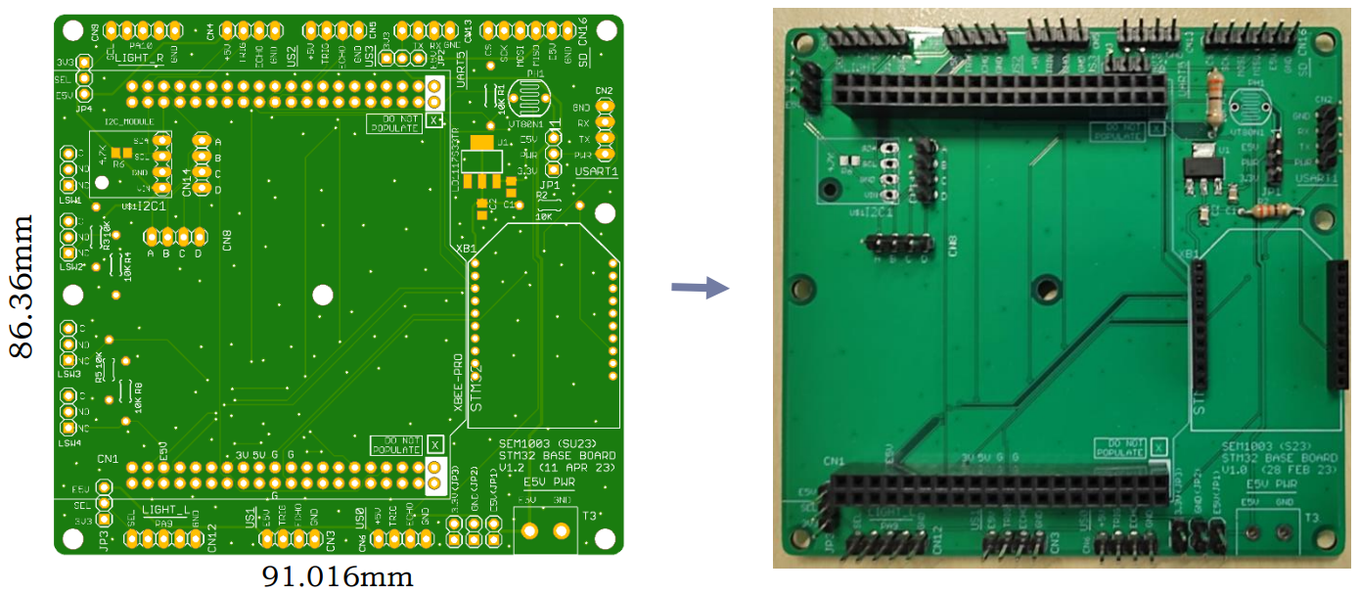

**Figure x: Visual representation of the Baseboard**

The baseboard provides power to not only the mezzanine board which is mounted on it but also to the STM32G474 Nucleo board, light module and ultrasound sensors.

### **3.1.3 Sensors**

1. **Ultrasound Sensors HC-SR04**

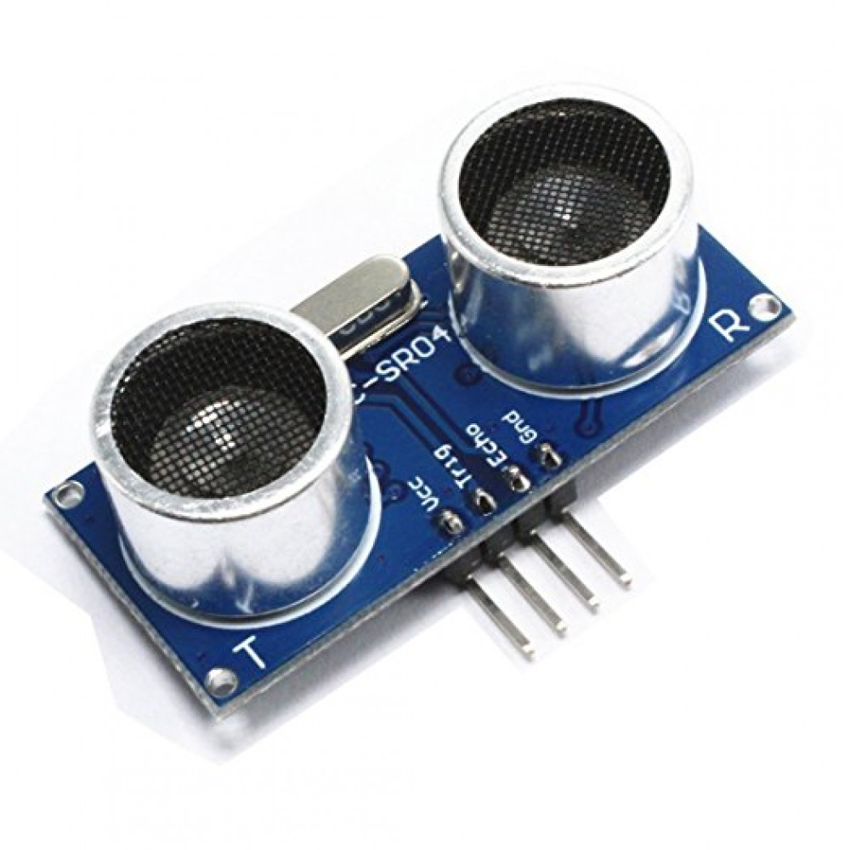

**Figure x: Visual representation of the Ultrasound Sensors**

1. **Time of Flight Sensors STM VL53L0X**

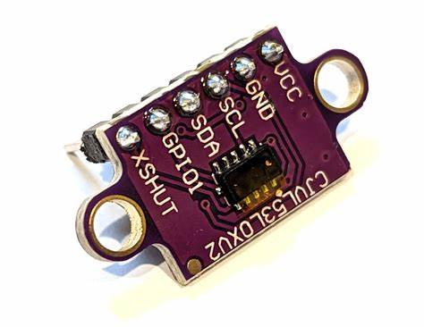

**Figure x: Visual representation of the ToF sensors**

### 3.1.4 Light Module

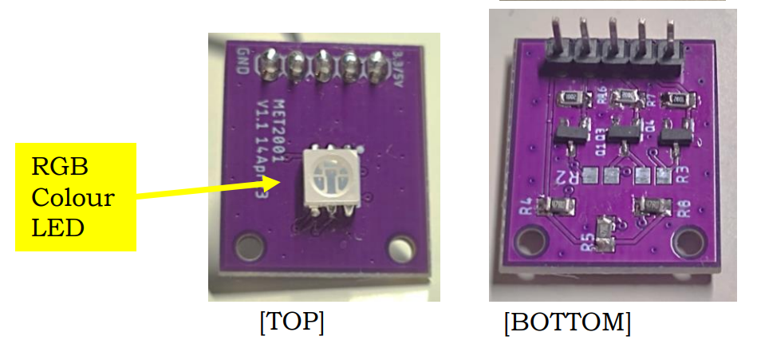

**Figure x: Visual representation of the LED Module**

The light module provided is powered by 3.3V from the baseboard. There are 3 GPIO pins that control the individual red, green and blue colours. There are 2 light modules that are attached on the AMR for demo 3. The light module used for demo 3 is to blink at 2Hz repeatedly when the AMR is in motion.

### 3.1.5 MP3 Module

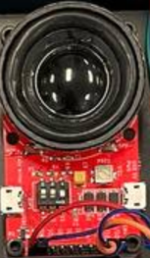

**Figure x: Visual representation of the UART MP3 Module and it’s speaker**

The MP3 module provided has an SD card with loaded MP3 files that are used for demo 3 when the AMR meets certain conditions. The MP3 module would then play the sound when it is turning left, right and moving forward. The MP3 module is powered by 5V, with transmit and receive signals connected with the baseboard.

## 3.2 Integration to meet Demo 3 Requirements

This section discusses how the team integrates the software and hardware into the AMR.

### **3.2.1 Software Integration**

**Demo 3 course**

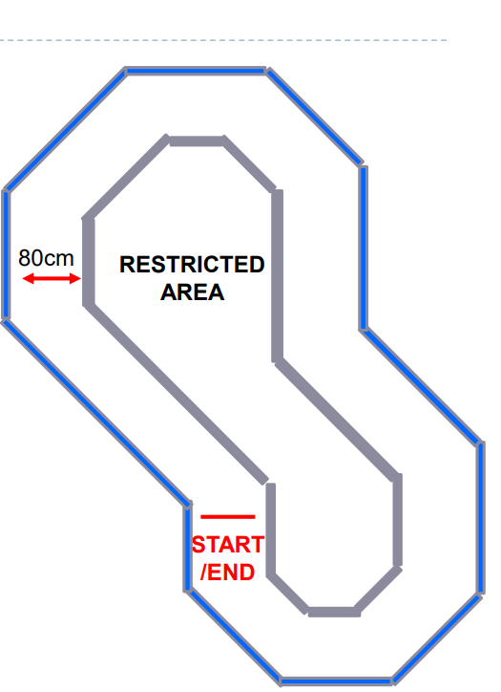

**Figure x: Visual representation of the course which the robot should manoeuvre for demo 3**

Using the Keil uVision 5 software the team created a wall hugging code to complete demo 3. The team's AMR autonomously traverses the given walled circuit at least twice clockwise and twice anti-clockwise, at 25 ticks/100ms. The code developed by the team utilises the 2 Time of flight sensors placed at a 45 degree position at the front of the AMR , it also utilises all 4 ultrasound sensors placed at the top, bottom, left and right side of the AMR.

By using all the ultrasound sensors and time of flight sensors the AMR is able to hug the wall and turn accordingly to the given track. The AMR is also able to stop its course when there is an obstacle detected in front.

In addition to movement the team implemented sound functions using the MP3 player module provided by professo’s Teck Ping Khoo and Foo Hong Fong. The sound functions include a stop, move forward, turn left and turn right sound effect, the stop sound can be heard when there is an obstacle in front of the AMR, the move forward sound is heard when the AMR is continuously moving straight, the turn left sound is heard when the AMR is turning left and lastly the turn right sound can be heard when the AMR is turning Right

Another function added to the teams AMR is a led light function, 2 led light modules were attached to the sides of the AMR. Firstly the team wired up both of the led light modules to the baseboard of the AMR. After the completion of wiring the components, the team proceeded to create a program to make both the led light modules blink at 2 hertz per second during movement of the AMR.

Lastly the team made improvements to the LCD screen attached to the AMR as an extra feature, the LCD screen displays the distance sensed by all 4 ultrasound sensors, as well as the distance sensed by the 2 time of flight sensor and also shows the direction that the AMR is moving.

### **3.2.2 Hardware Integration**

Ultrasonic Sensors:

* Connect the ultrasonic sensors to US0-US3 on the baseboard.
* Vcc, GND, Trigger and Echo pins must match the position of the pins on the baseboard so that the ultrasonic sensor is functional.

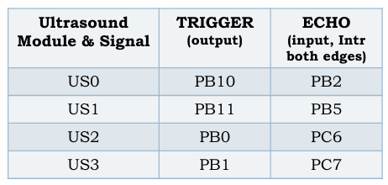

**Figure x: Ultrasonic sensors port assignments**

Laser Time-of-Flight Sensors:

* Connect the ToF sensors to the daughter board.
* VIN, GND, SDA, SCL, XSHUT and GPIO1 pins must match the position of the pins on the daughter so that the ToF sensor is functional.

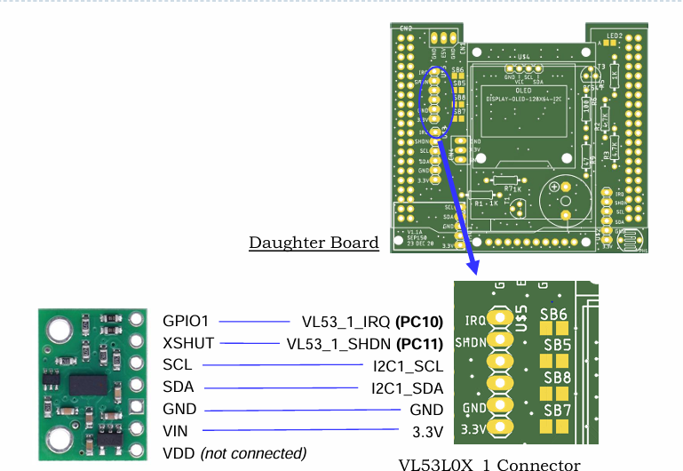

**Figure x: Pictorial representation of ToF1 sensor connection to daughterboard**

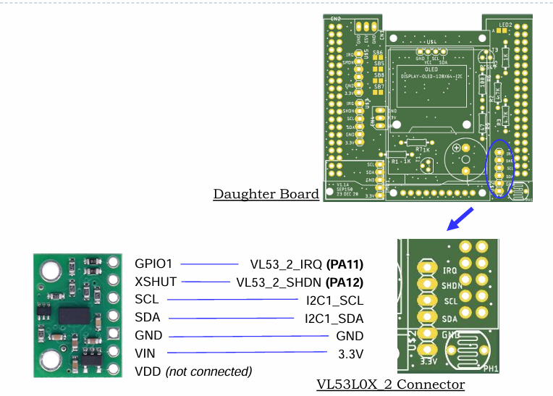

**Figure x: Pictorial representation of ToF2 sensor connection to daughterboard**

Light Module:

* Connect light modules to the baseboard as it has a respective placement for it. Able to emit the colours of Red, Blue and Green.
* Ensure Vcc (3.3V), GND and PA10/PA9 pins match the position of the pins on the baseboard so that the light module is functional.
* Colour of the light can be selected by interchanging the jumper wire of PA10 or PA9 to the middle 3 pins of the light module.

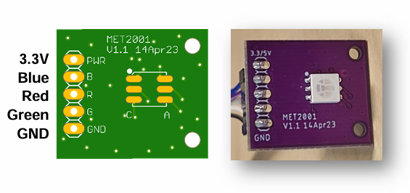

**Figure x: Pictorial representation of the light module connections**

MP3 Module:

* Connect MP3 modules to the baseboard as it has a respective placement for it.
* Ensure Vcc (3.3V), GND, TX(PC12) and RX(PD2) pins match the position of the pins on the baseboard so that the MP3 module is functional.

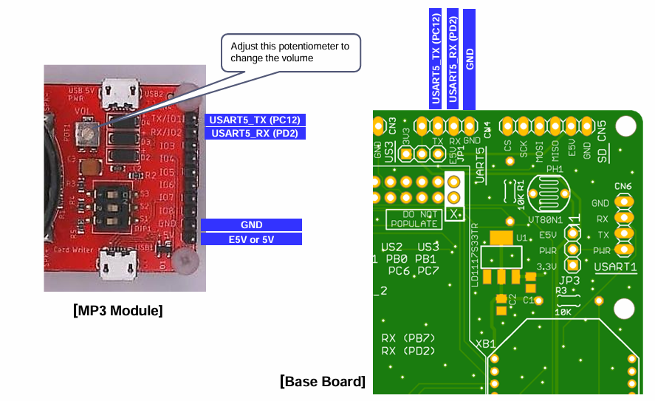

**Figure x: Pictorial representation of MP3 module connections to baseboard**

MCB:

* Connect the MCB to the baseboard.
* HTX and HRX pins must match the position of the pins on the baseboard so that the motor is functional.
* Ensure the Vcc (12V) and GND pins are connected to the power distribution board.

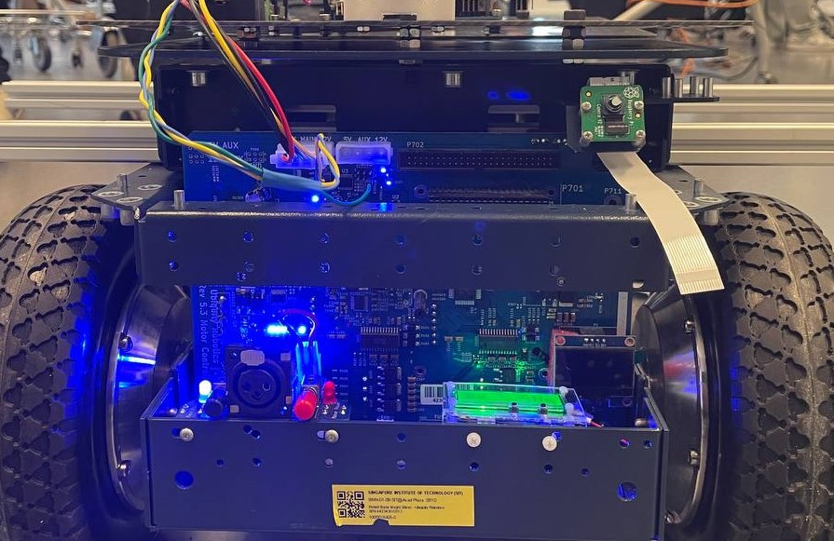

**Figure x: Connection from MCB to PDB and baseboard**

## 3.3 ECE Task assignment

This section of the report discusses how the team breaks down the problem statement into broader individual ECE tasks for each team member .

### 3.3.1 Code Integration

Before integrating the code into the AMR, the analysis of the various unit test codes for the various modules were done to understand how they work and the relevant communication protocols used. The relevant pins were also checked to ensure they are properly defined in the corresponding HAL and IRQ files.

To simplify merging and utilisation of code, functions, libraries, and macros were used. Custom libraries greatly helped to abstract different functions, keeping only the navigation algorithm in the main C files. This enables easy debugging and fine tuning later on.

### 3.3.2 Unit Testing

Before integrating the components into the tank, Bellamy, Shuan and Chai conducted unit testing to verify the functionality of each component. The components tested included:

* **ToF (Time-of-Flight) Sensors:** These sensors were tested to ensure accurate distance measurement and reliable operation under various conditions. The team tested the ultrasound sensors by using a measuring tape. A cardboard would be placed at each demarcated point and the readings could be viewed from the debug printf window once the testing code has been loaded into the STM32G474 Microcontroller. Due to the maximum range of the sensors being at 2 metres, the team took readings at every 10 cm till the 2 metre mark was reached.
* **Ultrasound Sensors:** The functionality of the ultrasound sensors was verified to confirm their ability to detect objects and measure distances accurately. The team tested the ultrasound sensors by using a measuring tape. A cardboard would be placed at each demarcated point and the readings could be viewed from the debug printf window once the testing code has been loaded into the STM32G474 Microcontroller. Due to the maximum effective range of the sensors being at 2 metres and having a maximum range of 4.5 metres, the team concluded that readings should be taken at every 10 cm till the 2 metre mark was reached.
* **LED Module:** The LED module was tested for correct operation, including colours, response to control signals, and overall reliability. The team wired the LEDs to the baseboard and tested the functionality of the lights by loading in a set of codes to the STM32G474 Microcontroller that would blink the LED at 2Hz. Once the blinking can be observed, the testing of the LED module can be deemed as successful.
* **MP3 Module:** The team tested the MP3 module to ensure it could play audio files correctly, respond to control commands, and integrate with other system components. Connecting the MP3 module to UART 5 and pins PC12 and PD2, loading the unit testing codes to the STM32G474 Microcontroller would activate the MP3 module and it would sound out the voice as intended.
* **Motor Control Board:** The motor control board was tested using the UART converter. By using the correct COM PORT, loading in the code directly into the converter would activate the motor and drive the wheels forward. Therefore, this step is essential as it verifies its capability to control the motor.

By performing these unit tests, the team ensured each component is functional before integrating them into the tank, this reduces the risk of issues during the final assembly and integration stages.

### 3.3.3 Wiring of electrical components

After completing unit testing, the next step involves wiring the electrical components. Proper wiring is crucial for the reliable operation of the system. Here’s an overview of how the wiring for each component should be approached:

* **ToF (Time-of-Flight) Sensors:**
  + **Power Supply:** Connect the VCC pin to a 5V power source and the GND pin to the ground.
  + **Communication:** Connect the SDA (data line) and SCL (clock line) pins to the corresponding pins on the microcontroller for I2C communication.
* **Ultrasound Sensors:**
  + **Power Supply:** Connect the VCC pin to a 5V power source and the GND pin to the ground.
  + **Trigger and Echo:** Connect the Trigger (TRIG) pin and Echo (ECHO) pin to the designated digital input/output pins on the microcontroller.
* **LED Module:**
  + **Power Supply:** Connect the VCC pin to the appropriate power source (3.3V) and the GND pin to ground.
* **MP3 Module:**
  + **Power Supply:** Connect the VCC pin to a 5V power source and the GND pin to the ground.
  + **Communication:** Use TX and RX pins to connect to the corresponding pins on the microcontroller for serial communication.
* **Motor Control Board to PDB:**
  + **Power Supply:** Ensure the motor control board has a stable power supply, using two 12V batteries.
  + **Motor Connections:** Connect the motor terminals HTX, RTX and ground pins to the baseboard for direction and speed control.

By following these guidelines, the wiring of the electrical components can be performed systematically, ensuring a robust and reliable system.

### 3.3.4 Baseboard and Power Distribution Board Soldering

The Baseboard and Power Distribution Board (PDB) are important for the Magni Robot System as a whole to function properly as it ensures proper power distribution and connectivity for the various components integrated together on the Magni Robot System.

* STM32 Connector (Base) Board:
  + Provides mezzanine mount for the STM32 Nucleo CPU board
  + Provides connections for power to the STM32 Nucleo board, sensors, LCD display, ESP32 module, light modules and ultrasound sensors
* Power Distribution Board
  + Acts as a central point for all the other boards on the Magni Robot System to get power from the main battery, ensuring stable and reliable operations.

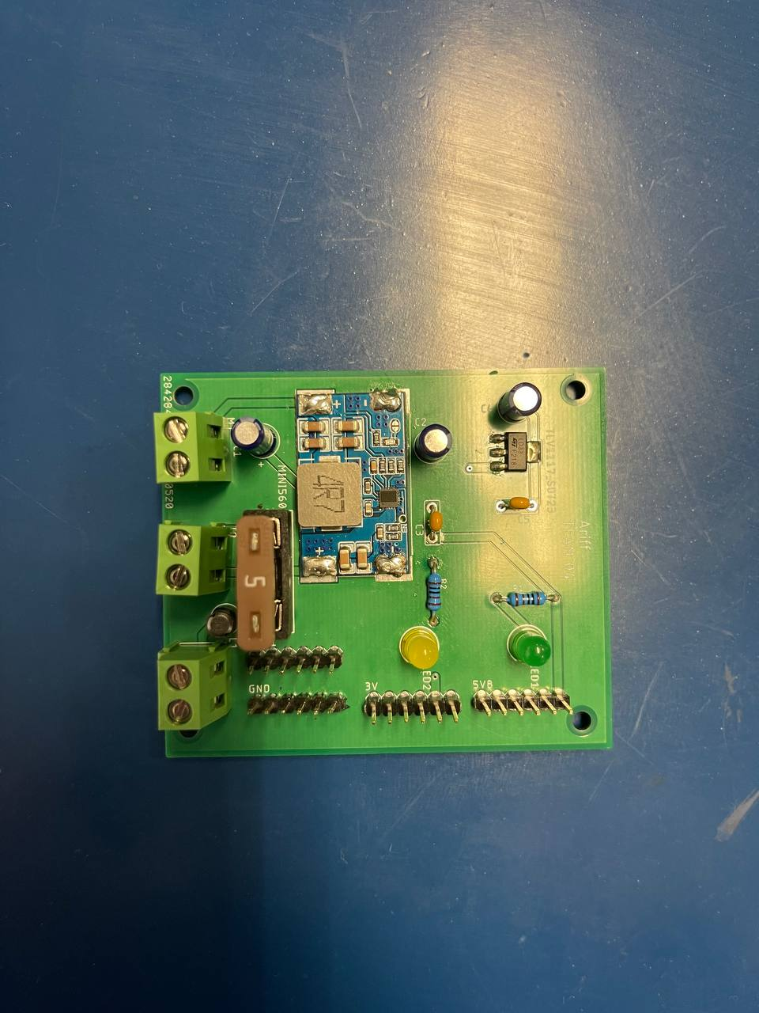

**Figure x: Visual representation of the Power Distribution Board (PDB)**

**with all components soldered on**

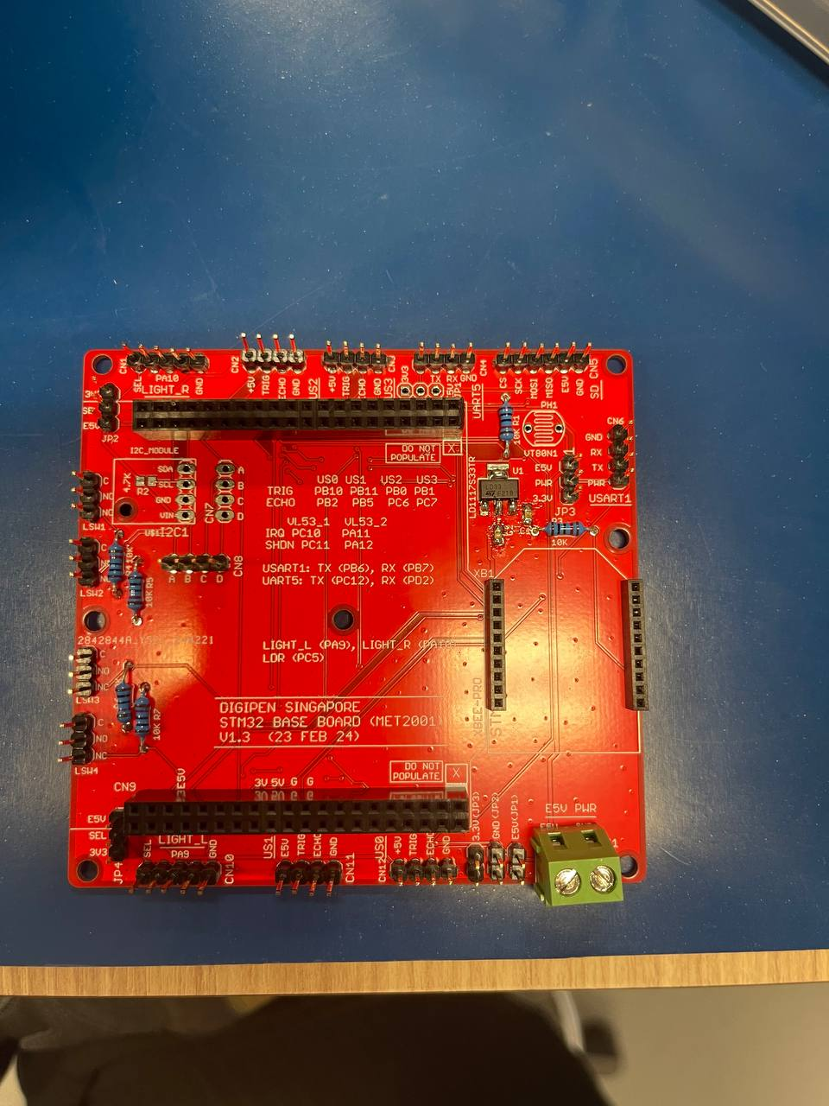

**Figure x: Visual representation of the Baseboard**

**with all components soldered on**

Both the baseboard and PDB are already fabricated for the project, with the PDB using a chosen PCB design from one of the group members. Pre-planning of component placement as well as solder priority on both boards is crucial in ensuring a smooth soldering process. Prior to soldering, a proper work area such as the Laboratory at DV-AP-SR2H was utilised with proper attire and personal protective equipment (PPE) such as safety glasses. The soldering techniques consist of the following two:

* Through-Hole Soldering
  + The soldering iron is placed onto the desired hole that needs to be soldered so that it comes into contact with the pad. It is heated up before placing the lead onto the component and pad so that a strong joint is formed to firmly secure the component from the back.
* Surface Mount Soldering
  + Similarly for surface mount components that need to be soldered, solder iron is applied onto the pads. A tweezer is then used to properly position the component onto the pad before solder iron is released.

Throughout the soldering process, frequent visual inspections are conducted with the help of assistant professors to ensure that the soldering process is of acceptable quality. Moreover, the digital multimeter was used to verify continuity between soldered points. A power up test was also conducted using the laboratory’s power supply to check if power is being supplied to the board correctly without any issues. It is important to ensure that no short circuits are present due to improper soldering such as cold joints or accidental solder bridges.

The soldering process is a critical step in the Magni Robot System. Proper planning, soldering techniques and quality checks ensure that the boards can function as intended and aid in the further development of the Magni Robot System as a whole.

# 4**. Literature Survey**

This section of the report discusses the project background information and research findings of other real-world products. This is done by comparing the components used in the demo 3 and real-world products.

## 4.1 Research Survey

The team then researched on robots that utilise wall-hugging / line-following algorithms and discussed the components used. The components comparison would give the team a better idea of the components which perform better and its position to be placed for accurate and consistent readings.

### 4.1.1 Line Follower Robot

The first product that the team researched on uses the line-following algorithm to design their robot. The components that the team would use to compare with are sensors and motor driver board.

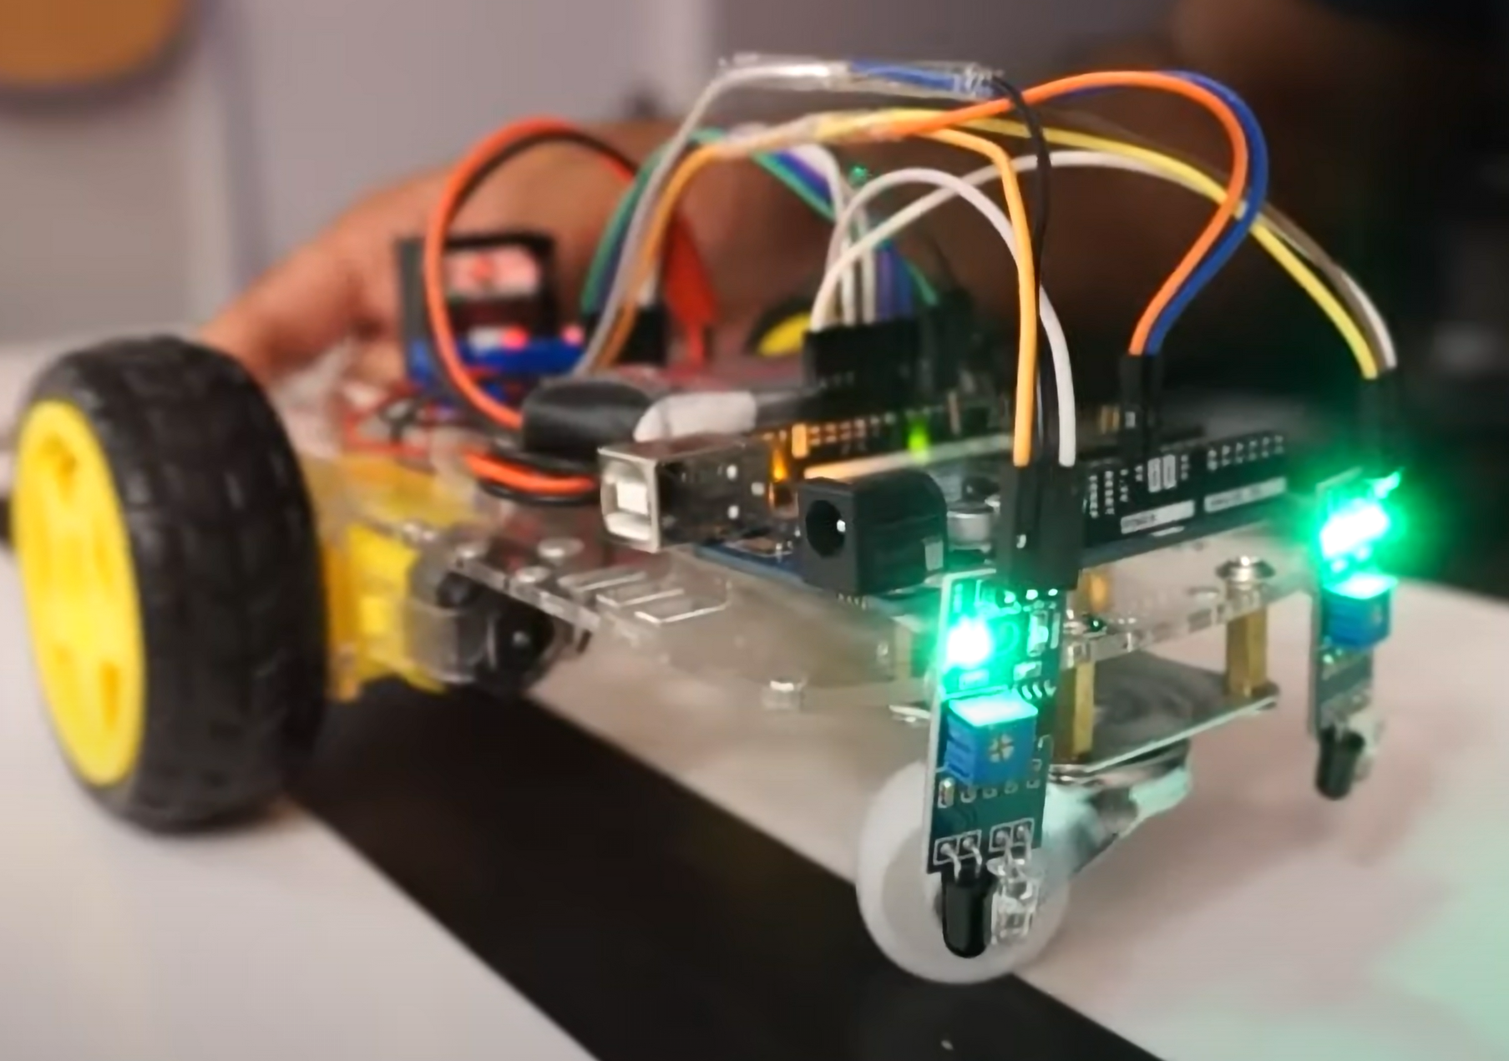

**Figure x: Line Following Robot**

The line following code is where the robot follows the black line shown in the figure above with the use of IR proximity sensors. These sensors are adjusted and coded such that once one of the sensors detects the black line, the robot would turn in the direction of where that sensor is placed.

In this scenario following the figure shown above, the robot’s right IR proximity sensor has one of its LEDs turned off. This indicates that the robot is strafing too far left, the robot will then start to turn right such that it follows the black line again. This would happen when the robot’s left IR sensor detects the black line and this process would be looped throughout the course of the maze.

### 4.1.2 Autonomous Wall Hugging Robot

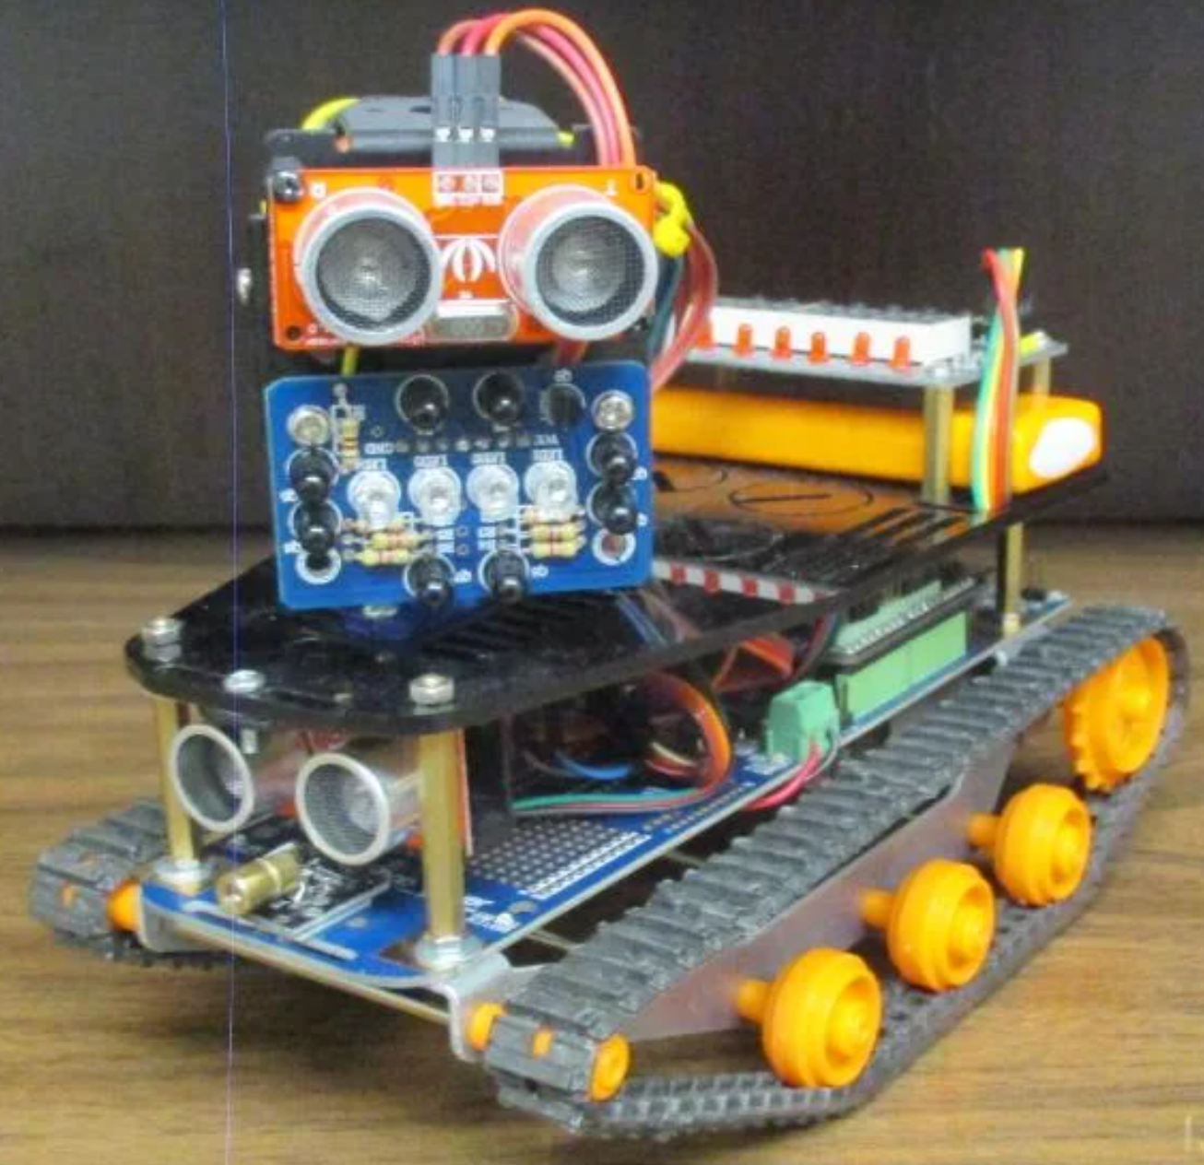

**Figure x: Wall Hugging Robot**

The wall hugging robot uses the ultrasound sensor to detect the distance of the robot to the wall and the robot would turn in the direction based on the values read by the sensor. The wall hugging algorithm is also incorporated in the team’s demo 3 to solve the customer specification.

## 4.2 Analysis and Comparison

This section of the report discusses the analysis made with the different components of the 2 products researched and compares its specifications and features. Thereafter, concluding why the components the team chose for demo 3 were used.

### 4.2.1 Light Distance Sensor

The comparison of the team’s VL53L0X ToF distance sensor and the line follower robot’s MLE00536 IR proximity sensor will provide the team with insights on which is the better sensor.

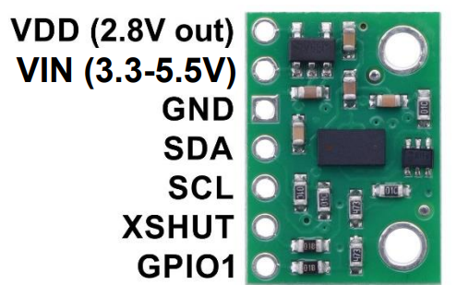

**Figure x: Visual representation of the VL53L0X ToF sensors**

**Specifications**

* Dimensions: 0.5” x 0.7” x 0.085” (13mm x 18mm x 2mm)
* Weight without header pins: 0.5g (0.02 oz)
* I2C serial interface (through SDA & SCL pins)
* Supply current: 10 mA (typical average during active ranging)
  + Varies with configuration, target & environment. (40mA -> peak current)
* Output format (I2C): 16-bit distance reading (mm)
* Minimum distance measuring range: 3 cm
* Max distance measuring range: 2 m
* Cost: $2.92

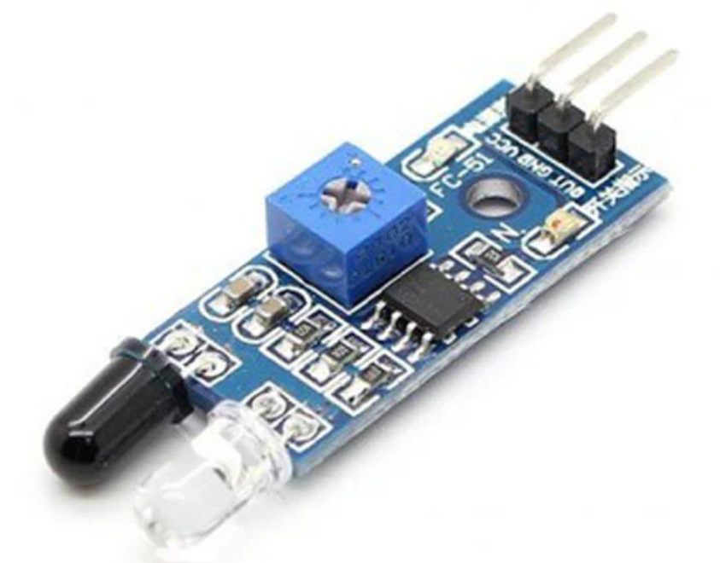

**Figure x: Visual representation of the MLE00536 IR proximity sensor**

**Specifications**

* Operational Voltage: 3.3 - 5V
* Ambient light & RGB colour sensing
* Proximity Sensing
* Gesture Detection
* Operating Range: 4-8in (10 - 20 cm)
* I2C interface (I2C Address: 0x39)
* Costs: $0.57

**Features**

* Used for obstacle sensing, colour detection
* Easy to use digital output
* Used for wireless communication and sensing IR remote signals
* Sensor comes with ambient light protection
* Sensor hole of 3mm diameter for easy mounting

Comparing the team’s ToF distance sensor and the researched MLE00536 IR distance sensor. The team realised that the IR sensor is cheaper than the ToF sensor that was used. However, the maximum operating range is only 20cm and it cannot be used as the AMR would be touching the wall during operation, this would cause the customer acceptance test to fail. Hence, the provided VL53L0X ToF distance sensor is the better option.

### 4.2.2 Ultrasonic Sensor

The comparison of the team’s HC-SR04 ultrasonic sensor and the autonomous wall hugging robot’s SKU101990004 ultrasonic measurement module / ping sensor would give the team a better idea.

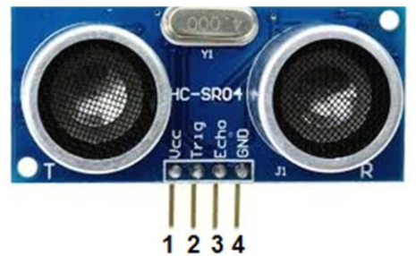

**Figure x: Visual representation of the HC-SR04 ultrasonic sensor**

**Specifications**

* Operating Voltage: 5V
* Static Current: < 2mA
* Output Signal: Electric Frequency Signal
  + High Level: 5V
  + Low Level: 0V
* Sensor Angle: < 15 degrees
* Detection Distance: 2cm - 450cm
* Precision: 3mm
* Input Signal Trigger: 10 μs
* Costs: $4.50

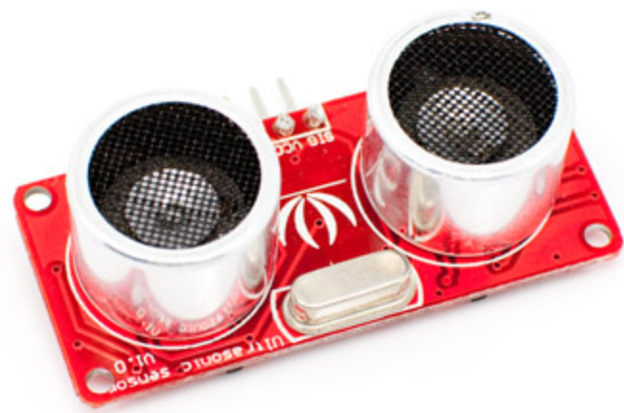

**Figure x: Visual representation of the SKU101990004 ultrasonic measurement module**

**Specifications**

* Dimension: 43 x 20 x 15 (mm)
* Operating Voltage: 5V
* Current Consumption: < 15mA
* Sensor Angle: < 30 degrees
* Detection Range: 3cm - 400cm
* Resolution: 1cm
* Input Trigger Pulse: 10 μs
* Costs: $19.90

Comparing the team’s Ultrasound sensor and the researched SKU101990004 ultrasonic measurement module. The team realised that the researched ultrasonic sensor is much more expensive than the sensor that was provided. The specifications do not differ much from each other as both sensors have the same detection range, operating voltage and input signal trigger.

The slight difference between both sensors is the type of objects that is more suitable for detection between each sensor. The SKU101990004 sensor is more suitable for smaller objects whereas the HC-SR04 ultrasonic sensor is more accurate with objects that have a larger surface area as specified in the datasheet. With demo 3 having walls that span across the maze, the HC-SR04 ultrasonic sensor is more preferred than the 3 pin SKU101990004 ultrasonic measurement module to address the problem statement for our AMR.

### 4.2.3 Motor Control Board

The team researched on the Motor Control Board that is used on the Magni robot to further understand the various pins and connections on the MCB, but the main focus is on the connectors that the team used for demo 3.

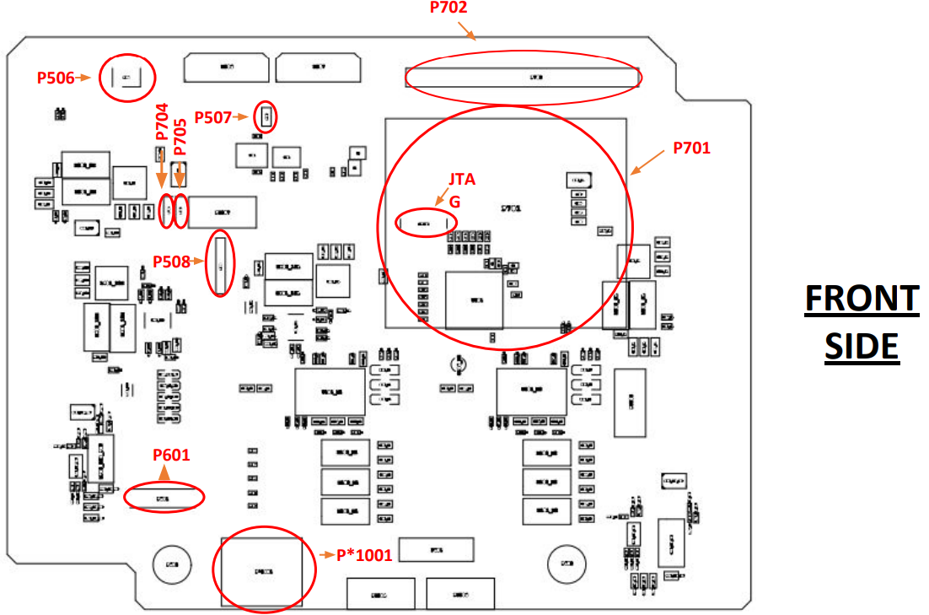

Figure x; Front side pinout diagram of MCB

**Pin Connections**

* Connector P506: Pins connection to GND

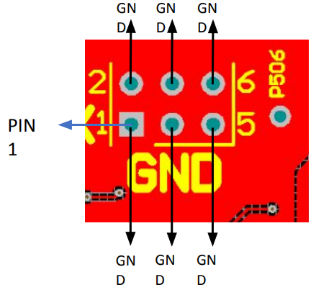

* Connector M506:

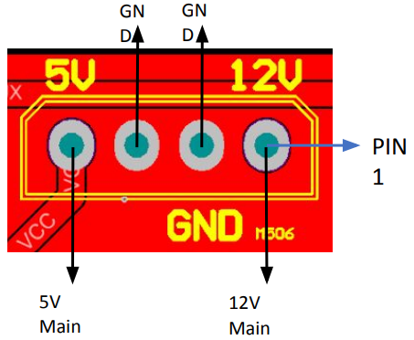

Figure x : Pin connection for Connector M506

The team uses this connector to provide power to the rest of the components by sending it to the PDB. The PDB is able to step down the 12V voltage to 5V and 3.3V for the rest of the components. The 12V cannot directly be connected to the components as it will short and burn the MCUs and sensors.

* Connector M507: Pins connection to 12V and 5V Aux, as well as GND

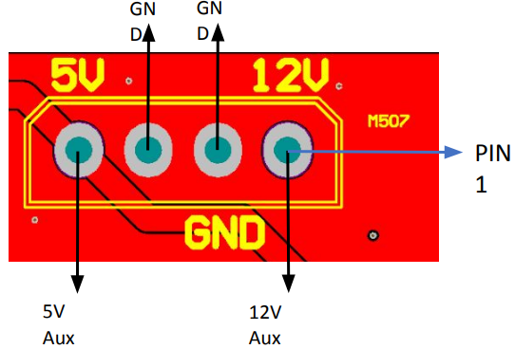

* Connector P702: Pins connection to 24V IN, 3V3, 5V, SDA, SCL, GND and P1-P40

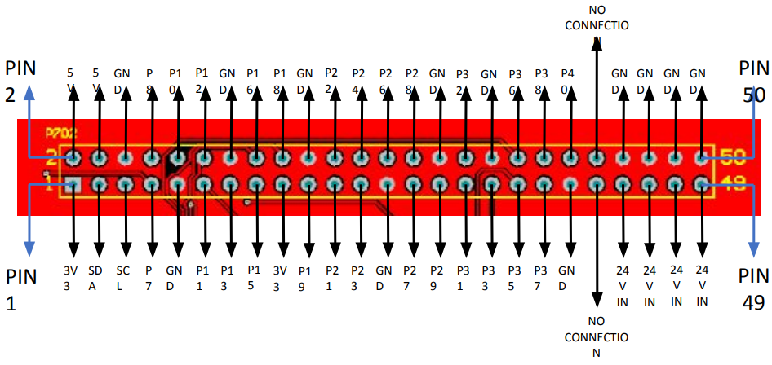

* Connector P507:

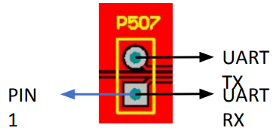

The team uses this connector P507 to all the MCB to communicate with the MCUs, via UART lines TX for transmit and RX for receive. These lines provide a communication signal that enables the AMR to move the motor via coding.

* Connector JTAG201: Pins connection for Program Data and Clock, XRES, 5V, GND

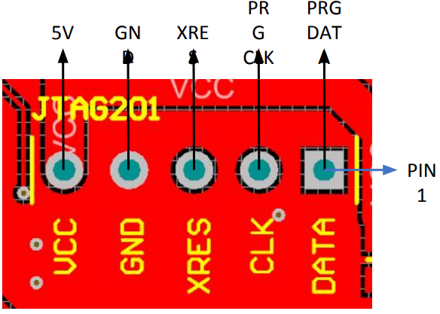

* Connector P701: Pins connection to 3V3, 5V, SDA, SCL, GND and P1-P40

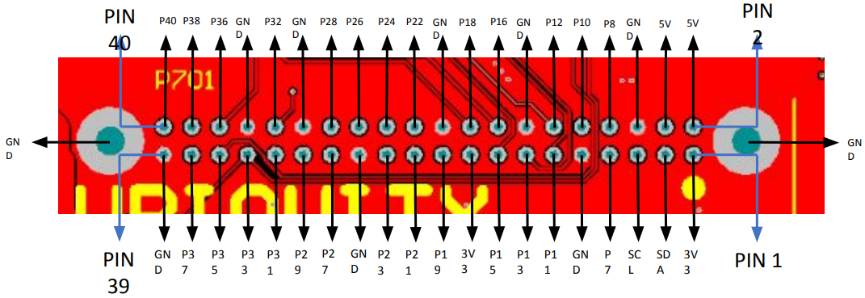

* Connector P704: Pins connection to GND, 3V3, P31

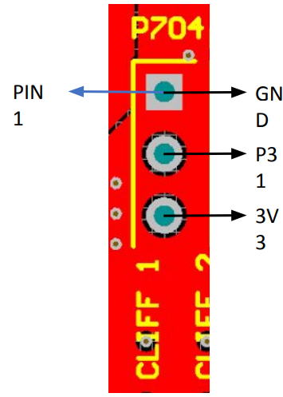

* Connector P705: Pins connection to GND, 3V3, P33

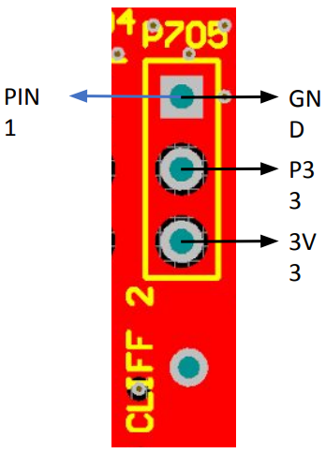

* Connector P508: Pins connection to GND, 5V, UART TX and RX

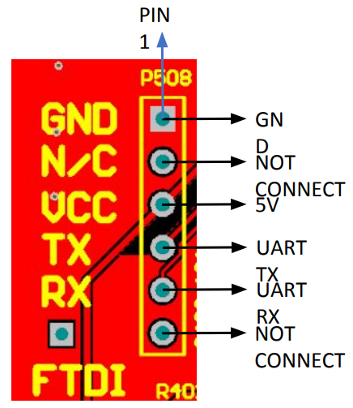

* Connector P601: Pins connection to 24V IN, GND, ENABLE POWER & MOTOR

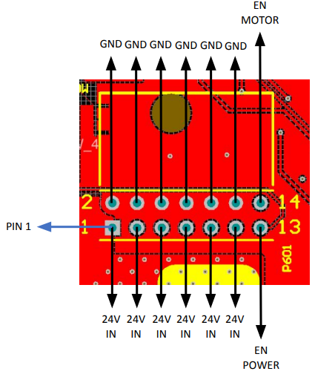

* Connector P*1001: Pins connection to 24V IN, MOTORC PWR GD, GND, MOTORC EN

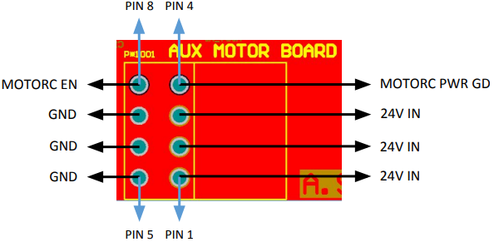

# 5. Algorithm

The navigation algorithm of the AMR takes into consideration the positions of the various sensors around the robot. Some of the sensors like the left and right ultrasonic are positioned tactically to counter the way the robot moves on its front differential drive and how the rear castor wheel reacts with each turn.

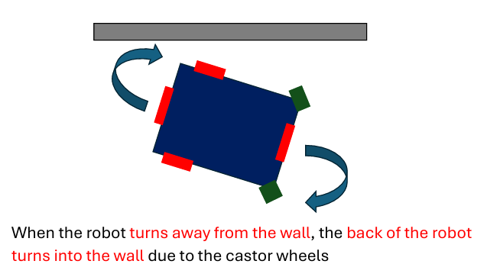

**Figure x: Visual representation of how the robot manoeuvres**

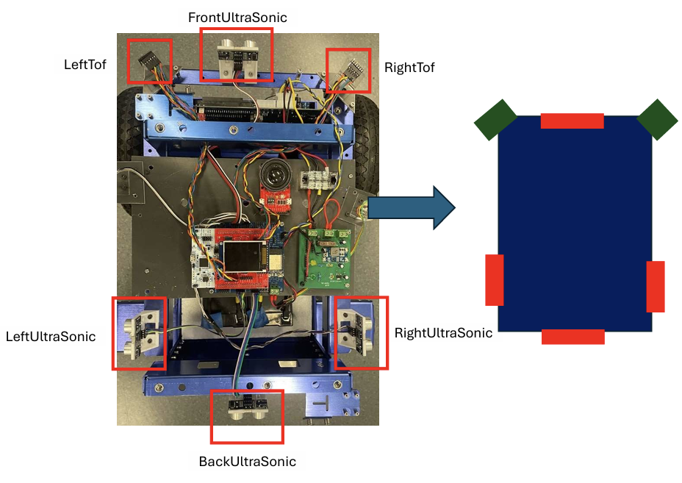

**Figure x: Image of the placement of each component on the AMR**

The algorithm is based on the different possibilities and use cases that may occur while navigating the course.

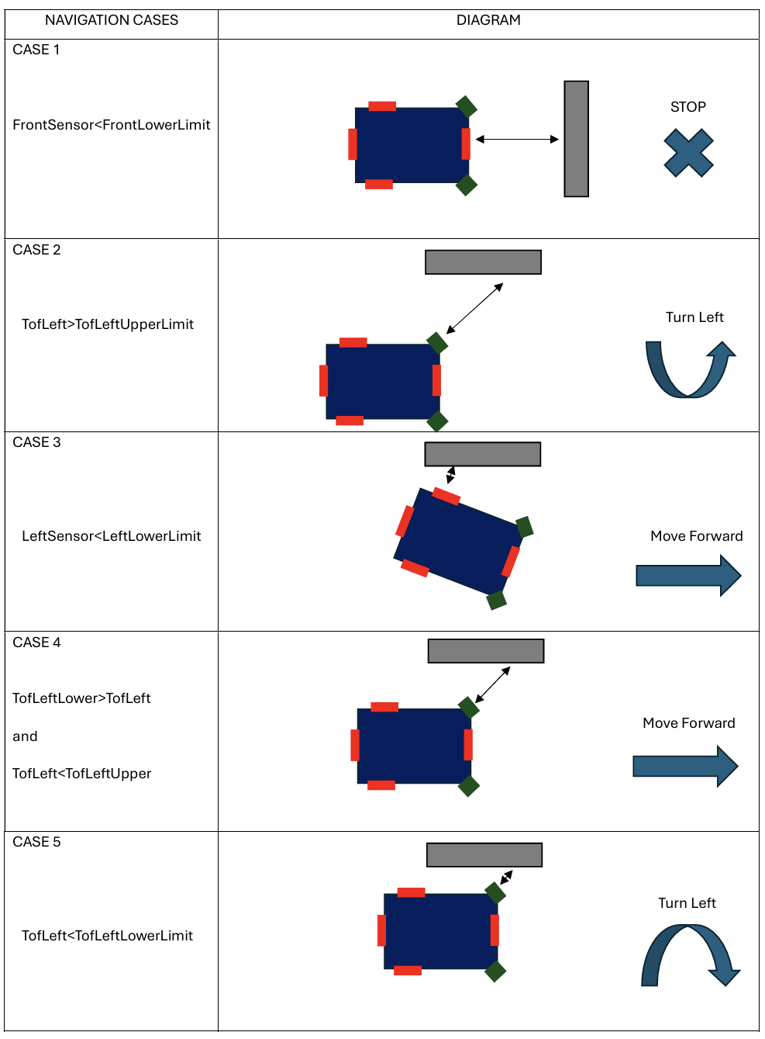

**Figure x: Visual representation of how the robot manoeuvres when obstacles arises**

It can be seen that the robot was asked to move forward when the back sensor sees the wall. This is to interrupt the current turn after clearing the wall and move away from it.

## 5.1 Code Design.

The code design uses several key principles that contribute to its efficiency, maintainability, and responsiveness. These principles include the use of abstraction, efficient handling of hardware interactions through interrupts, and user defined functions.

**1. Efficiency through Abstraction**

The code uses abstraction layers to manage hardware components and functionality. This is evident in the use of multiple header files and function definitions that abstract complex hardware interactions into simpler, reusable functions. A custom library was also created to abstract the LCD initialisation and functions leaving the main c file focusing on the navigation. This makes it simpler to troubleshoot and fine tune the parameters

**2. Interrupt-Driven Design**

The code efficiently handles real-time events and hardware interactions through the use of interrupts. This approach minimises CPU idle time and ensures timely responses to critical events. Key examples include:

* **External Interrupts:** Functions like EXTI13_BTN_IRQHandler() handle button presses, allowing the CPU to respond immediately when these events occur.
* **Callback Functions:** The use of callback functions, such as main_cbI2cDone() and main_cbUS0OnReady(), allows the code to handle asynchronous events efficiently. When an event is triggered, the corresponding callback function is executed, processing the event without polling or wasting CPU cycles. This is specifically used to update the control flags of the robot, as the sensors only receive values when the interrupt occurs. Continuous polling of sensor states would waste clock cycles.

**3. User Defined Functions and Maintainable Design**

The code is organised into clearly defined functions , each responsible for a specific aspect of the system's functionality. This modularity enhances code readability, maintainability, and scalability. Examples include:

* **Sensor Management:** Separate functions and handlers manage different types of sensors, making it easy to check and update sensor states
* **Readability:** Functions like Wallhug_control() and CompareSensors() helps the user concentrate on the high level tasks like parameter tuning and navigation algorithm

## 5.2 Implementation of Code

The main navigation algorithm is broken down into 2 main functions.  
  
**1. compareSensors():**

This function compares the various sensors and updates the relevant flags that indicate their state. The states of the other flags are also reset.

The function is called only when there is an interrupt triggered by any of the sensors indicating that its value is ready to be read. Placing it here makes the code more efficient as there would not be any unnecessary polling that can lead to wasting clock cycles.

In this algorithm, the stop and avoidance is also prioritised with the if else logic. Shown below is the flowchart and its code implementation.  
  
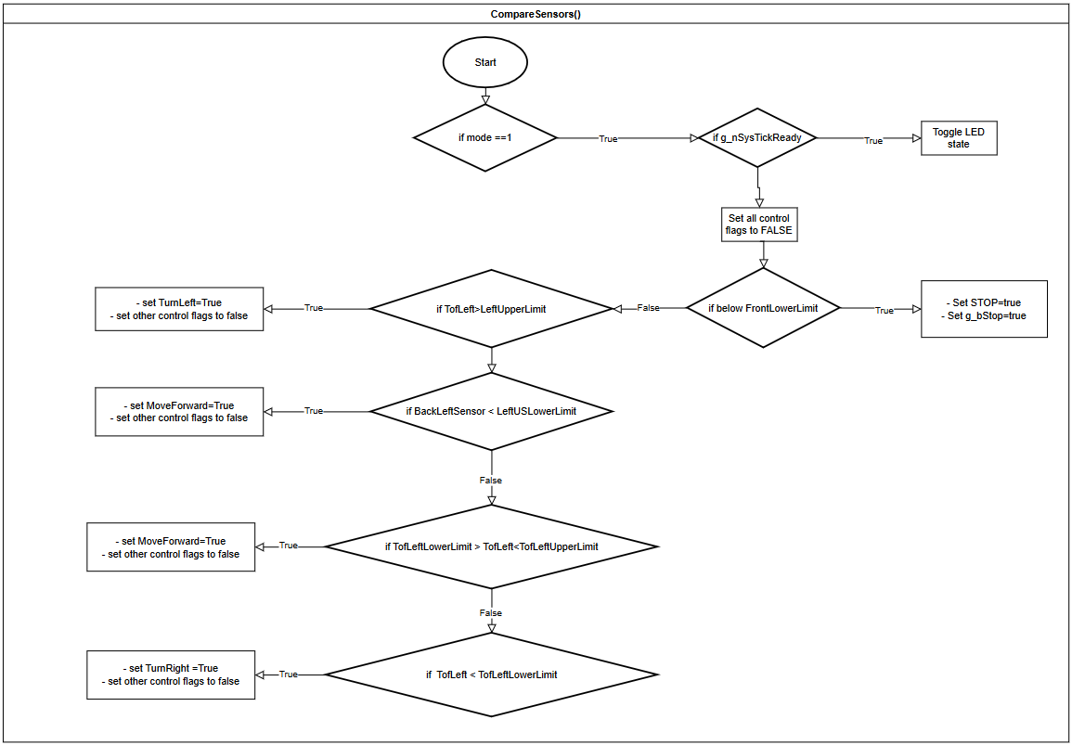

**Figure x: Flowchart of how the robot checks and avoid obstacles when manoeuvring**

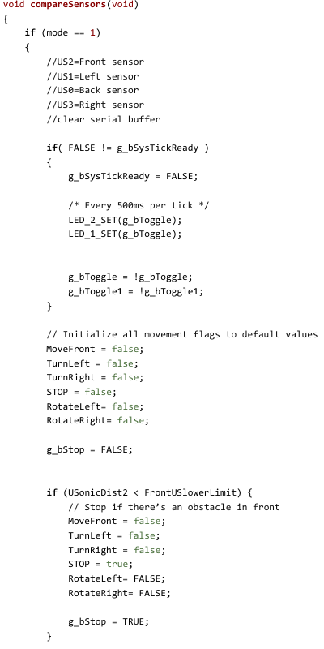

**Figure x: Image of code which shows how the robot checks and avoid obstacles when manoeuvring**

**2. WallHug_control():**

This function controls the movement of the AMR. It calls various predefined functions from the library and executes them accordingly. The LEDs are also toggled here.

The function is called in the main loop as the robot is always required to move and react accordingly when there is a change of state in the sensors.

Shown below is the flowchart and its code implementation.

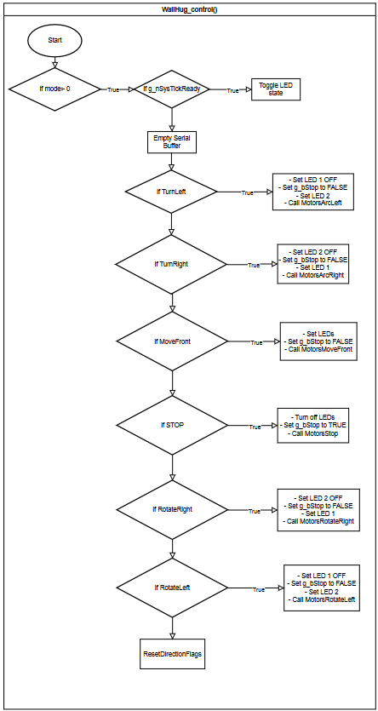

**Figure x: Flowchart of how the robot keeps close to the wall when manoeuvring**

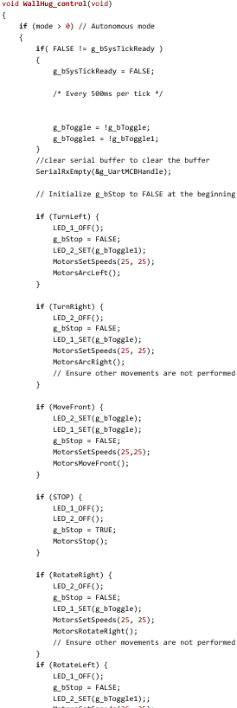

**Figure x: Image of code which shows how the robot keeps close to the wall when manoeuvring**

## 5.3 Testing of Application

This section of the report discusses the team’s strategy and process to test the design of the code as well as its real-world application, summarising the errors encountered and how the team managed to solve them.

### 5.3.1 Testing Methodology

**Simulation and Emulation:**

* **Initial Testing:** The initial testing phase involved placing the AMR on top of a wooden block to elevate the wheels. The sensors were then triggered by hand to see if they reacted accordingly.
  + - Confirmed the sensors can be triggered by range of distances
    - Confirmed the motors were able to react accordingly

**Unit Testing:**

* **Function Isolation:** Each function within the code was tested independently to ensure correctness. Key functions such as compareSensors() and WallHug_control() were rigorously tested with predefined inputs to validate their output.
  + **compareSensors():**
    - Tested with simulated sensor data to ensure proper flag updates.
    - Verified reset of flags by reading the lcd or the debug window when new sensor data is read.
  + **WallHug_control():**
    - Tested motor control logic in isolation to ensure accurate movement commands.
    - Validated LED toggling based on sensor inputs.

**Integration Testing:**

* **Module Interaction:** The integration testing phase involved combining different modules—sensor management, motor control, and navigation logic—to ensure they work seamlessly together.
  + **Sensor to Motor Coordination:**
    - Verified that sensor data correctly influenced motor control decisions.
    - Ensured timely updates and responses to sensor triggers.
  + **Interrupt Handling:**
    - Confirmed that interrupts were correctly triggering relevant functions.
    - Ensured that callback functions processed sensor data without unnecessary CPU usage.

**Field Testing:**

* **Real-World Environment:** The final testing phase involved deploying the AMR at the course to evaluate its performance under practical conditions.
  + **Test Scenarios:**
    - Designed test scenarios that included common obstacles and navigation challenges.
    - Simulated typical usage conditions to assess the robustness of the navigation algorithm.

### 5.3.2 Results

**Performance Metrics:**

* **Obstacle Detection Accuracy:**
  + Achieved an average detection accuracy of 95% for obstacles within the sensor range.
  + Improved accuracy with iterative testing and calibration.
* **Navigation Efficiency:**
  + Measured the time taken to navigate through the test course.
  + Observed a significant reduction in navigation time after optimization of the algorithm.
* **Response Time:**
  + Ensured timely reactions to changing environmental conditions.

**Error Analysis:**

* **Issues Encountered:**
  + Initial sensor calibration errors leading to false positives/negatives.
  + Motor control issues causing deviations from the planned path.
* **Resolutions:**
  + Recalibrated sensors and fine-tuned their sensitivity.
  + Adjusted motor control parameters to ensure accurate path following.
* **Remaining Limitations:**
  + Limited performance in highly dynamic environments with rapidly changing obstacles.
  + Occasional delays in sensor data processing under high-load conditions.

# 6. Validation

This section of the report discusses how the team analysed whether the AMR passed the customer acceptance test.

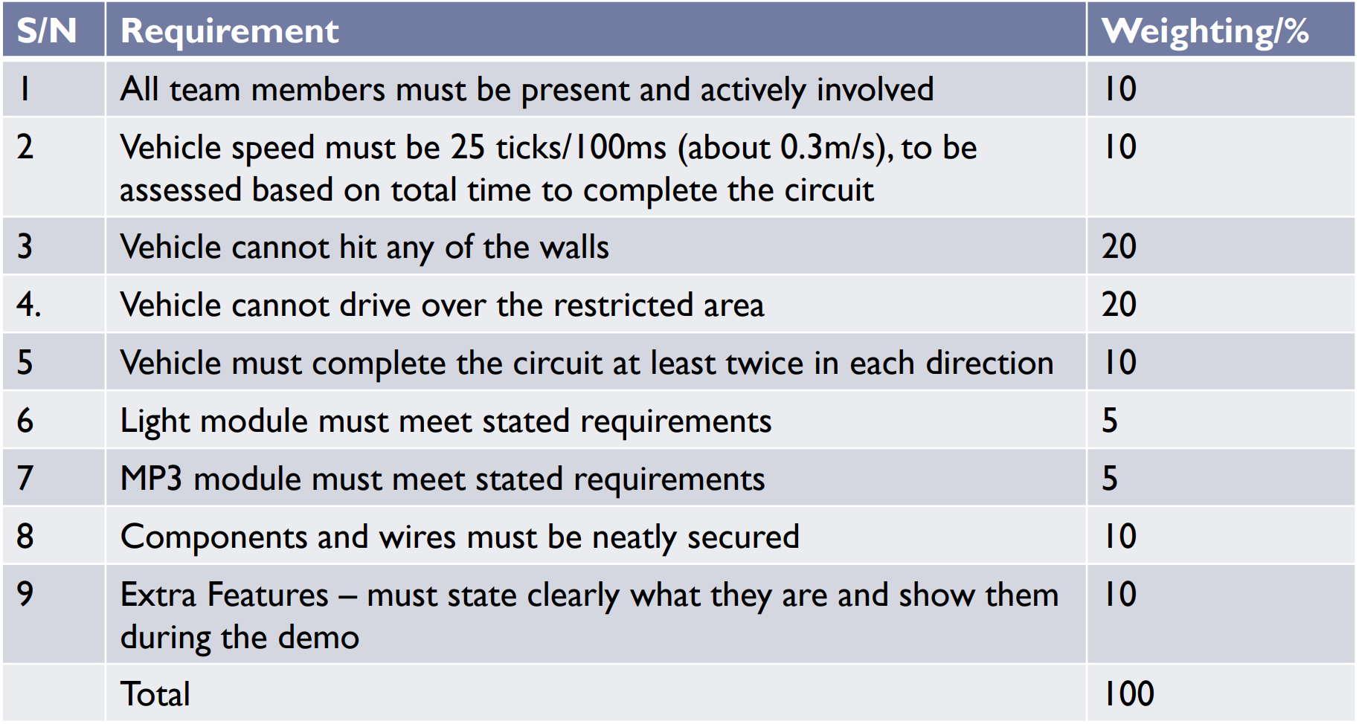

Figure x: Rubrics for Demo 3

Based on the above rubrics, the team ensured that each component is included in the robot. Unit testing of each component was done as well as it allowed the team to check if the items can function as intended by the customer. Additionally, the code which the team produced was also tested on the circuit prior to the actual demo day. This was an essential task for the team as clearing the circuit successfully would satisfy requirements 2,3,4 and 5.

# 7. Conclusion

This section of the report concludes and summarises the team’s reflection and key learning points. Each team member’s contribution is also provided in this section of the report.

## 7.1 Reflection and Learning Points

The primary goal of the project is to utilise the STM32G474 Microcontroller and create an autonomous navigation Robot (AMR) that can manoeuvre around a cricut using a wall hugging algorithm.

**Team Collaboration**:

* Effective communication and collaboration among team members with different expertise (electrical, mechanical, software) are crucial for project success.
* Clear documentation of tasks to be done and completion facilitated in better coordination.

**Communication:**

* Clear and consistent communication within the team facilitated smooth collaboration and problem-solving. Regular meetings and updates ensured that all members were aligned and working towards common goals.

## 7.2 Team Contributions

| **Declaration of Percentage of Contribution** | | |
| --- | --- | --- |
|  | | |
| Agreement or otherwise to the whole team award of the same grade. Please select appropriately from the following:  **YES** - THE TEAM HAS DISCUSSED THIS AND I AGREE THAT EVERYONE CONTRIBUTED EQUALLY. Proceed to sign the document.  **NO** - THE TEAM HAS DISCUSSED AND I AGREE ON THE %CONTRIBUTION BY DIFFERENT MEMBERS. Enter the % contribution below: | | |
| Team Member | %contribution (Total 100%) | Main Contributions Listed (discuss with team) - attach additional pages if needed. |
| Bellamy Woo Zhen Yu | 20 | Fabrication, Wiring, Components Testing, Report |
| Chai Ze Xuan | 20 | Fabrication, Wiring, Components Testing, Report |
| Shaun Ong Zhi Peng | 20 | Fabrication, Wiring, Components Testing, Report |
| Muhammad Ariff | 20 | CAD, Coding, Report |
| Low Min Wei | 20 | Fabrication, Baseboard Soldering, Report |